\begin{figure}[htb]

\centering

\begin{tikzpicture}%\draw[help lines] (0,0) grid (8,4);

\draw (2.6,1)--(2.6,3);

\draw (3.6,1)--(3.6,3);

\draw (3.1,1) ellipse[x radius = 0.5, y radius=0.2];

\draw (3.1,3) ellipse[x radius = 0.5, y radius=0.2];

\node at(3.1, 3.5) {bar A}

\draw[very thick,->] (3,2.2)--(4,2.2);

\draw[very thick,<-] (3,2)--(4,2);

\node at(4.2,3.5) {bar B}

\draw (3.7,1)--(3.7,3);

\draw (4.7,1)--(4.7,3);

\draw (4.2,1) ellipse[x radius = 0.5, y radius=0.2];

\draw (4.2,3) ellipse[x radius = 0.5, y radius=0.2];

\draw[very thick,->] (1,1)--(1,3);

\node at(1,0.5) {$T_{0}$};

\node at(1,3.5) {$T_{L}$};

\end{tikzpicture}

\caption{Inter-exchanging of heat among aluminum bars is in equilibrium, so we only consider the overall vertical heat flux from bottom to top, i.e. from highe temperature to low temperature. }\label{twobar}

\end{figure}

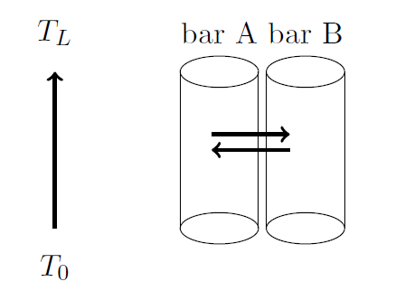

%%%%%%%%%%%%%%%%%%%%%%%%%%%%%%%%%%%%%%%%%%%%%%%%%%%%%%\\begin{figure}[htb]

\centering

\begin{tikzpicture}

%\draw[help lines] (0,0) grid (8,5);

\draw (1,1)--(6,1);

\draw (1,2)--(6,2);

\draw (1,1.5) ellipse[x radius = 0.2, y radius=0.5];

\draw (6,1.5) ellipse[x radius = 0.2, y radius=0.5];

\draw[very thick,->] (1,1.5)--(6,1.5);

\draw[very thick,<->] (1,3.2)--(6,3.2);

\node at(3.5,3.2) {L};

\node at(3.5,0.5) {heat flux: q};

\node at(1,0.7) {$T_{0}$};

\node at(6,0.7) {$T_{L}$};

\end{tikzpicture}

\caption{A 1-D model of heat sink}\label{bar}

\end{figure}

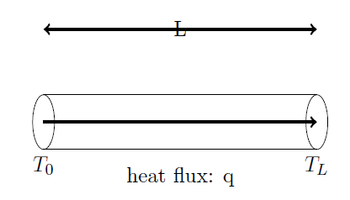

%%%%%%%%%%%%%%%%%%%%%%%%%%%%%%%%%%%%%%%%%%%%%%%%%%%%%%%

\begin{figure}[htb]

\centering

\begin{tikzpicture}

%\draw[help lines] (0,0) grid (8,4);

\draw (1,2)--(4,4)--(8,4)--(5,2)--(1,2)--(1,1)--(5,1)--(5,2);

\draw (5,1)--(8,3)--(8,4);

\draw[dashed] (4,4)--(4,3)--(8,3)--(4,3)--(1,1);

\draw[fill=gray] (1,1)--(1,0.5)--(5,0.5)--(5,1)--(1,1);

\draw[fill=gray] (5,1)--(5,0.5)--(8,2.5)--(8,3)--(5,1);

\draw[dashed] (3.6,1.5)--(3.6,2.5);

\draw[dashed] (4.6,1.5)--(4.6,2.5);

\draw[dashed] (4.1,1.5) ellipse[x radius = 0.5, y radius=0.2];

\draw (4.1,2.5) ellipse[x radius = 0.5, y radius=0.2];

\draw[very thick,->] (0.5,1)--(0.5,2);

\node at(-0.5,1.5) {heat flux};

\node at(0.5,0.5) {$T_{0}$};

\node at(0.5,2.5) {$T_{L}$};

\node at(5,0.7) {Heat Source: chips};

\node at(6.5,3.2) {Heat Sink};

\end{tikzpicture}

\caption{A simplified rectangular-shaped heat sink connected with a heat producing chip at the bottom}\label{box}

\end{figure}

%%%%%%%%%%%%%%%%%%%%%%%%%%%%%%%%%%%%%%%%%%%%%%%%%%%%%%

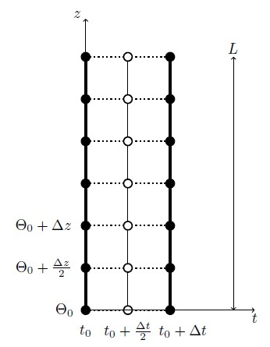

\newcommand{\mycircle}[1]

{\draw[fill=white,line width=1pt] (#1) circle[radius=1mm]}

\newcommand{\mycircleB}[1]

{\draw[fill=black,line width=1pt] (#1) circle[radius=1mm]}

\begin{figure}[htb]

\centering

\begin{tikzpicture}

%\draw[help lines] (-2,-1) grid (3,8);

\draw[ultra thick] (-1,0)--(-1,6);

\mycircleB{-1,0};

\mycircleB{-1,1};

\mycircleB{-1,2};

\mycircleB{-1,3};

\mycircleB{-1,4};

\mycircleB{-1,5};

\mycircleB{-1,6};

\node at (-1,-0.5) {$t_{0}$};

\draw (0,0)--(0,6);

\draw[thick,dotted] (-1,0)--(1,0);

\draw[thick,dotted] (-1,1)--(1,1);

\draw[thick,dotted] (-1,2)--(1,2);

\draw[thick,dotted] (-1,3)--(1,3);

\draw[thick,dotted] (-1,4)--(1,4);

\draw[thick,dotted] (-1,5)--(1,5);

\draw[thick,dotted] (-1,6)--(1,6);

\mycircle{0,0};

\mycircle{0,1};

\mycircle{0,2};

\mycircle{0,3};

\mycircle{0,4};

\mycircle{0,5};

\mycircle{0,6};

\node at (0,-0.5) {$t_{0}+\frac{\Delta t}{2}$};

\draw[ultra thick] (1,0)--(1,6);

\mycircleB{1,0};

\mycircleB{1,1};

\mycircleB{1,2};

\mycircleB{1,3};

\mycircleB{1,4};

\mycircleB{1,5};

\mycircleB{1,6};

\node at (1.3,-0.5) {$t_{0}+\Delta t$};

\draw[->] (-1,0)--(3,0);

\draw[->] (-1,0)--(-1,6.9);

\node at (3,-0.2) {$t$};

\node at (-1.2,7) {$z$};

\draw[<->] (2.5,0)--(2.5,6);

\node at (2.5,6.2) {$L$};

\node at (-1.5,0) {$\Theta_{0}$};

\node at (-2,1) {$\Theta_{0}+\frac{\Delta z}{2}$};

\node at (-2,2) {$\Theta_{0}+\Delta z$};

\end{tikzpicture}

\caption{A finite difference method}\label{fig:grid}

\end{figure}

%%%%%%%%%%%%%%%%%%%%%%%%%%%%%%%%%%%%%%%%%%%%%%%%%%%%5

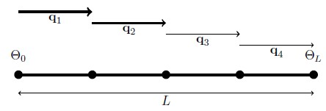

\newcommand{\mycircle}[1]

{\draw[fill=white,line width=1pt] (#1) circle[radius=1mm]}

\newcommand{\mycircleB}[1]

{\draw[fill=black,line width=1pt] (#1) circle[radius=1mm]}

\begin{figure}[htb]

\centering

\begin{tikzpicture}

%\draw[help lines] (-2,-1) grid (9,2);

\draw[ultra thick] (0,0)--(8,0);

\mycircleB{0,0};

\mycircleB{2,0};

\mycircleB{4,0};

\mycircleB{6,0};

\mycircleB{8,0};

\node at (0,0.5) {$\Theta_{0}$};

\node at (8,0.5) {$\Theta_{L}$};

\draw[ultra thick,->] (0,1.7)--(2,1.7);

\node at (1,1.5) {$\textbf{q}_{1}$};

\draw[very thick,->] (2,1.4)--(4,1.4);

\node at (3,1.2) {$\textbf{q}_{2}$};

\draw[thick,->] (4,1.1)--(6,1.1);

\node at (5,0.9) {$\textbf{q}_{3}$};

\draw[->] (6,0.8)--(8,0.8);

\node at (7,0.6) {$\textbf{q}_{4}$};

\draw[<->] (0,-0.5)--(8,-0.5);

\node at (4,-0.7) {$L$};

\end{tikzpicture}

\caption{Four equal segments of the metal bar}\label{fig:grid}

\end{figure}

%%%%%%%%%%%%%%%%%%%%%%%%%%%%%%%%%%%%%%%%%%%%%%%%%%%

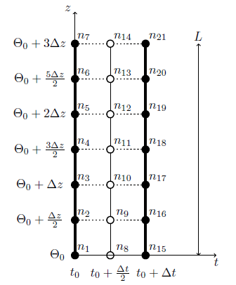

\newcommand{\mycircle}[1]

{\draw[fill=white,line width=1pt] (#1) circle[radius=1mm]}

\newcommand{\mycircleB}[1]

{\draw[fill=black,line width=1pt] (#1) circle[radius=1mm]}

\begin{figure}[htb]

\centering

\begin{tikzpicture}

%\draw[help lines] (-2,-1) grid (3,8);

\draw[ultra thick] (-1,0)--(-1,6);

\mycircleB{-1,0};

\mycircleB{-1,1};

\mycircleB{-1,2};

\mycircleB{-1,3};

\mycircleB{-1,4};

\mycircleB{-1,5};

\mycircleB{-1,6};

\node at (-1,-0.5) {$t_{0}$};

\draw (0,0)--(0,6);

\draw[thick,dotted] (-1,0)--(1,0);

\draw[thick,dotted] (-1,1)--(1,1);

\draw[thick,dotted] (-1,2)--(1,2);

\draw[thick,dotted] (-1,3)--(1,3);

\draw[thick,dotted] (-1,4)--(1,4);

\draw[thick,dotted] (-1,5)--(1,5);

\draw[thick,dotted] (-1,6)--(1,6);

\mycircle{0,0};

\mycircle{0,1};

\mycircle{0,2};

\mycircle{0,3};

\mycircle{0,4};

\mycircle{0,5};

\mycircle{0,6};

\node at (0,-0.5) {$t_{0}+\frac{\Delta t}{2}$};

\draw[ultra thick] (1,0)--(1,6);

\mycircleB{1,0};

\mycircleB{1,1};

\mycircleB{1,2};

\mycircleB{1,3};

\mycircleB{1,4};

\mycircleB{1,5};

\mycircleB{1,6};

\node at (1.3,-0.5) {$t_{0}+\Delta t$};

\draw[->] (-1,0)--(3,0);

\draw[->] (-1,0)--(-1,6.9);

\node at (3,-0.2) {$t$};

\node at (-1.2,7) {$z$};

\draw[<->] (2.5,0)--(2.5,6);

\node at (2.5,6.2) {$L$};

\node at (-1.5,0) {$\Theta_{0}$};

\node at (-2,1) {$\Theta_{0}+\frac{\Delta z}{2}$};

\node at (-2,2) {$\Theta_{0}+\Delta z$};

\node at (-2,3) {$\Theta_{0}+\frac{3\Delta z}{2}$};

\node at (-2,4) {$\Theta_{0}+2\Delta z$};

\node at (-2,5) {$\Theta_{0}+\frac{5\Delta z}{2}$};

\node at (-2,6) {$\Theta_{0}+3\Delta z$};

\node at (-0.75,0.2) {$n_{1}$};

\node at (-0.75,1.2) {$n_{2}$};

\node at (-0.75,2.2) {$n_{3}$};

\node at (-0.75,3.2) {$n_{4}$};

\node at (-0.75,4.2) {$n_{5}$};

\node at (-0.75,5.2) {$n_{6}$};

\node at (-0.75,6.2) {$n_{7}$};

\node at (0.35,0.2) {$n_{8}$};

\node at (0.35,1.2) {$n_{9}$};

\node at (0.35,2.2) {$n_{10}$};

\node at (0.35,3.2) {$n_{11}$};

\node at (0.35,4.2) {$n_{12}$};

\node at (0.35,5.2) {$n_{13}$};

\node at (0.35,6.2) {$n_{14}$};

\node at (1.35,0.2) {$n_{15}$};

\node at (1.35,1.2) {$n_{16}$};

\node at (1.35,2.2) {$n_{17}$};

\node at (1.35,3.2) {$n_{18}$};

\node at (1.35,4.2) {$n_{19}$};

\node at (1.35,5.2) {$n_{20}$};

\node at (1.35,6.2) {$n_{21}$};

\end{tikzpicture}

\caption{A finite difference method}\label{fig:grid}

\end{figure}

%%%%%%%%%%%%%%%%%%%%%%%%%%%%%%%%%%%%%%%%%%%%%%%%%

